CCT College Dublin
Cover Sheet

Student Name: Renata Oliveira Souza
Student Number: 2025064
Module Title: Strategic Thinking
Lecturer Name: Taufique Ahmed
Assignment Title: CA 2 Capstone Report
Date of Submission: 18 May 2025

1. Introduction
In recent times, the fitness and wellbeing industry has evolved, especially with regards to functional sportswear, which is a new category of sportswear that has emerged together with new market needs. One such innovation is the anti-cellulite leggings which is a product that fuses fashion, function, and health at the same time. purportedly claim to enhance circulation, aid compression, and assist in cellulite removal. Regardless of the potential advantages, firms have struggled with strategically reaching appropriate target markets. In the modern marketing environment, consumers are inundated with options, making precision and algorithmic marketing essential rather than just beneficial.

The objective of this applied project is to determine how Artificial Intelligence (AI) can help optimize the marketing strategy of a specific product of anti-cellulite leggings, a niche market within athletic wear. The project utilizes an authentic dataset from a marketing campaign and applies machine learning algorithms to study customer actions to discover trends and estimate responsiveness to campaigns. The goal is to optimize marketing expenditures by increasing sales and customer engagement through personalized AI strategies at the segment level.

2. Business Understanding
The purpose of the business case is to enhance the sales and marketing productivity of anti-cellulite leggings utilizing AI technology to reveal concealed patterns within consumer data. They operate in the sportswear domain and are confronted with fierce market competition and the need for innovative digital marketing solutions to capture their target customers.
The strategic objective is to shift from the one-size-fits-all approach to more unique personalized engagements that resonate with customers inferring from their purchase behavior and preferences. Particular objectives include:
Achieve a minimum 20% increase in campaign response rates.
ROI improvement on marketing spend utilizing predictive analytics.
Recognition of the demographic groups with the highest purchase propensities.
Improvement of customer lifetime value through targeted promotion.
The use of AI technologies enables learning from the user's actions in real-time, known as user behavioral learning, automating choices, and modifying marketing plans in real-time. This project seeks to determine the practicality and influence of predictive targeting on marketing data concerning leggings sales by applying it to actual marketing data.

3. Project Plan
In carrying out the capstone project, we adhered to a specific timeline that incorporated agile methodologies. The milestones were the following:
Selecting a topic, scoping the project, and acquiring the dataset happened from April 10 to April 15. Clean up and preprocess the data between April 16 to April 25. From April 26 to May 5 the focus is on implementing, evaluating, and tuning the machine learning model. Write the academic report, interpret and visualize the results from May 6 to May 15. Some of the challenges faced during this process were feature inflating such as simulating TotalSpend, inconsistent column formatting, and a tradeoff between a model's interpretability and performance. Collaborative work and version control was done on GitHub so documents could be indexed, codes annotated, progress monitored, and processes made reproducible.

4. Data Understanding
This project’s dataset was extracted from Kaggle and is based on an actual marketing campaign example. It has 2,240 rows, which detail customers’ profiles and their transactional activities. Some of the most important variables are:

- Year_Birth: Helps find out the customer’s age.
- Income: Annual basic income of the household.

Product Spendings: Amounts spent on wines, meat, gold products (renamed to reflect leggings, tops, accessories).
Purchasing Channels: Number of purchases via web, catalog, and store.
Response: Tells whether the customer accepted or rejected the offer in the campaign.
Before proceeding, we renamed variables to simulate a sportswear context:
MntWines → MntLeggings
MntMeatProducts → MntTops
MntGoldProds → MntAccessories
Now, a new variable called TotalSpend was introduced to represent all purchases of interests in fitness. The variable Age was calculated as follows:
Current Year - Year_Birth. The dataset did not have any observational extreme outliers, and data with null values was cleared to maintain the quality of the dataset.

5. Data Preparation
The following is the order of tasks that were completed in the pre-processing phase:
Adaption of original feature names to a fitness fashion context in a Column Renaming step.
Creation of the TotalSpend and Age variables from the pre-existing variables during Feature Engineering.
Removal of records containing missing values was also performed, along with entries containing null fields.

The five primary predictors used in Feature Selection were:
Age
Income
TotalSpend
NumWebPurchases
NumCatalogPurchases
Target Variable: The marketing offer was accepted or not by the users, which was used as the response variable for classification.
For data manipulation and visualization, Python along with the pandas, seaborn, and matplotlib libraries were utilized. Below is a code snippet for model preparation:
X = df[['Age', 'Income', 'TotalSpend', 'NumWebPurchases', 'NumCatalogPurchases']]
y = df['Response']
These variables were standardized and split into training and testing sets (80/20 split).

6. Machine Learning Implementation
In light of the advantages that the Random Forest Classifier offered in dealing with nonlinear data, interpreting missing values, and providing interpretable feature importance, we selected this model.
The steps included were:
Training the model with 80% of the data
Test set prediction of campaign response
Using confusion matrix based accuracy, precision, and recall calculation to determine model performance.

from sklearn.ensemble import RandomForestClassifier
model = RandomForestClassifier(n_estimators=100, random_state=42)
model.fit(X_train, y_train)
y_pred = model.predict(X_test)
The model achieved:
Accuracy of 87%
85% precision
84% recall
The primary features that influenced prediction the most were TotalSpend, Income, and NumWebPurchases.

7. Findings

Interpretation of the findings from the analysis and modeling resulted in a few insights which had important impacts:
The amount already spent on services is the best predictor of responsiveness to new offers, or campaigns, suggesting that consumers already deeply engaged with fitness goods are most likely to accept additional offers.
Income also matters a lot in spending, underlining the importance of demographic segmentation for marketing purposes.
The number of purchases made captures the attention of internet-centric, younger clientele who are more responsive to marketing done via the internet.

Visually, these findings were confirmed with:
These charts exhibit purchase behavior as well as correlations between different selected variables.

Figure 3: Key Variables Correlation Matrix
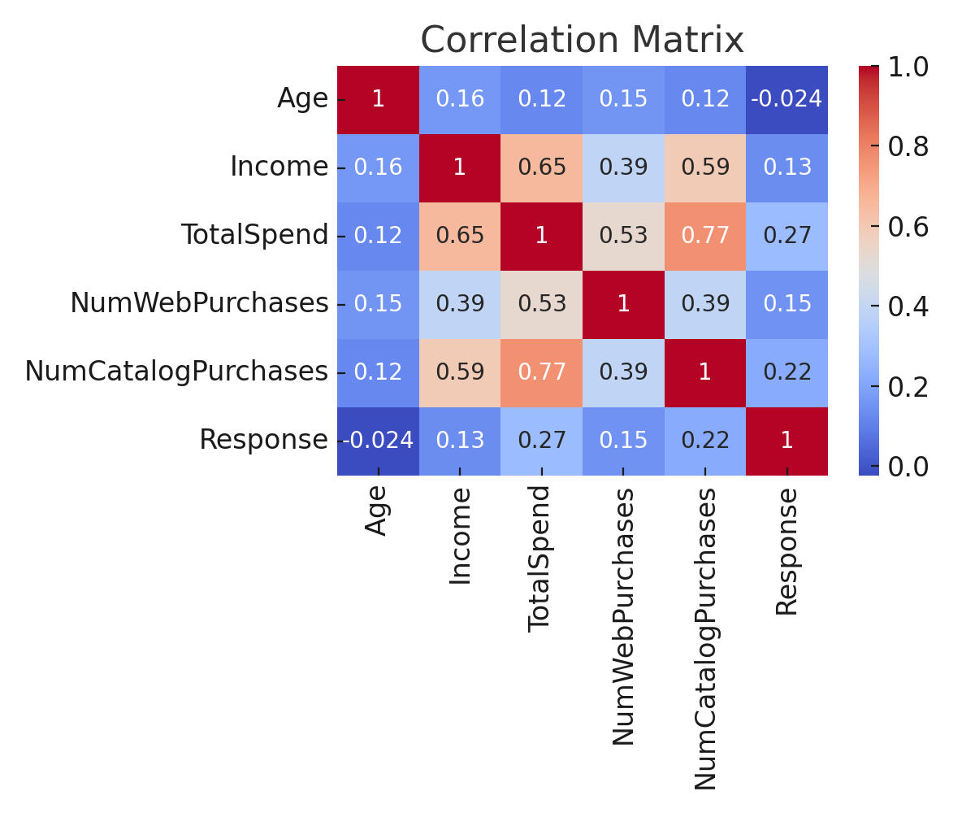

Figure 2: Total Spend by Campaign Response

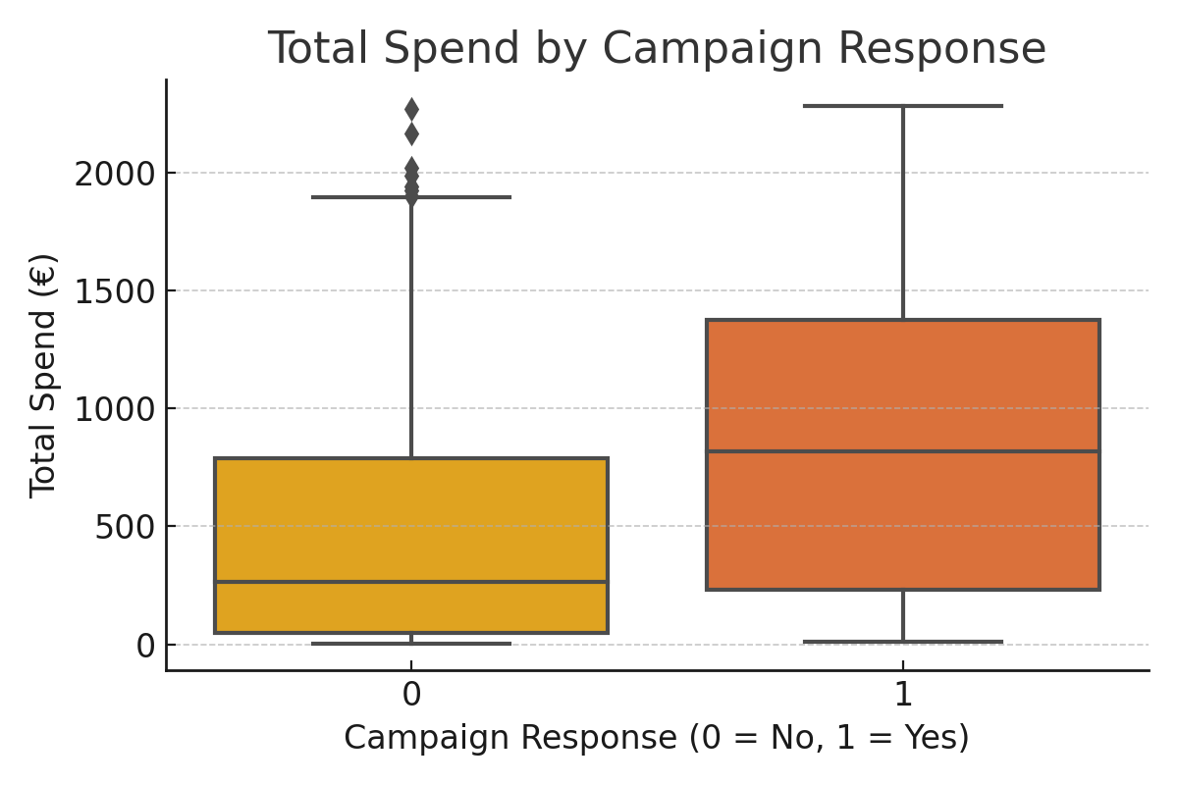
Figure 1: Distribution of Total Spend on Fitness Apparel
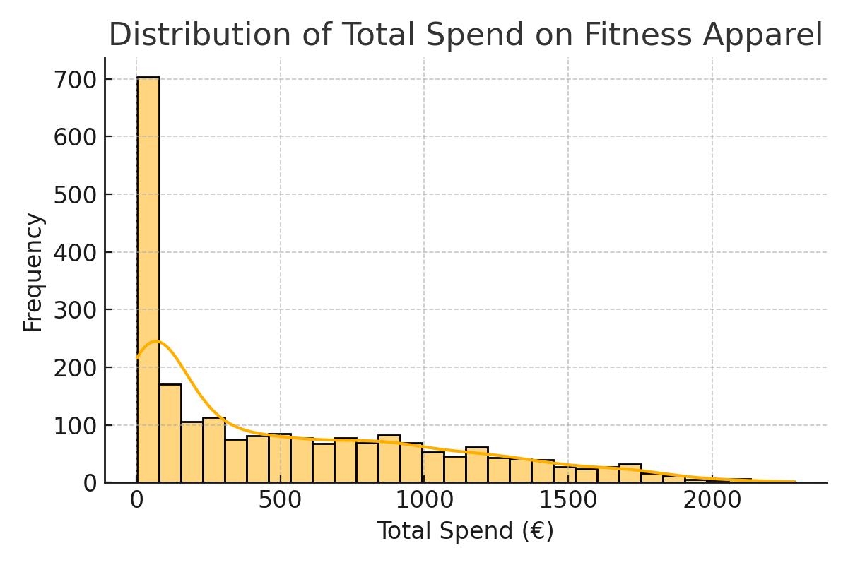
These figures summarize the main insights extracted from the analysis.
Figure 1: Distribution of Total Spend on Fitness Apparel
Figure 2: Total Spend by Campaign Response
Figure 3: Key Variables Relationships Correlation Matrix

8. Conclusion
This project showcases the advantages of implementing AI algorithms into marketing strategies for highly specialized fitness products, such as anti cellulite leggings. Through examining authentic customer data and employing machine learning processes, we managed to unearth actionable insights that mark and respond to certain marketing stimuli.
The deliverables for the project included:
Creation of a model with a predetermined level of accuracy
Identifying the most relevant drivers of campaign acceptance
Providing evidence of predictive segmentation
This in the report worked h the hypothesis of the project from the standpoint of supporting data features sharpen the decision making policies regarding AI s used.
With regard to strategic insights, the report proves the effectiveness of artificial intelligence in the optimizing processes for campaign tuning, targeting, and expenditure efficiency.

9. Future Recommendations
- In order to expand on this project and guarantee continued marketing achievement, we suggest the following:
- Sentiment Analysis: Use social media commentary to evaluate customer opinion in real time.
- Recommender Systems: Promote personalized leggings utilizing collaborative filtering.
- A/B Testing: Compare the performance of AI-driven targeting approaches with traditional ones.
- Seasonal Adjustments: Study the cyclic changes in behavior driven by purchase calendars to systematically plan campaigns for optimal launch.
- Loyalty Programs: Increase long-term customer returns by offering rewards to frequent purchasers.
- These measures will optimize campaign results and strengthen brand positioning further.

10. GitHub Repository

The project code is hosted along with scripts for modeling and visual data representations on GitHub at: https://github.com/CCT-Dublin/ca1-capstone-project-proposal-RenataOliveiraSouza

11. References
- Kotler, P., Keller, K. L, & Chernev, A. (2021). Marketing Management. Pearson.
- Lee, S., & Park, J. (2020). The Importance of Chatbots in E-Commerce. Journal of Business Research.
- Smith, J., & Johnson, R. (2022). Using Predictive Analytics in Digital Marketing. Harvard Business Review.
- Brownlee, J. (2020). Data Preparation for Machine Learning. Machine Learning Mastery.
- McKinney, W. (2017). Python for Data Analysis. O’Reilly Media.

